Hangman Game

USER GUIDE

Introduction

[Scope and purpose]

To provide a timeless and engaging program that challenges and entertains players of all ages, enhancing vocabulary skills through an intuitive and visually appealing gameplay UI. This game aims to be a go-to choice for casual gamers, educational institutions, and word puzzle enthusiasts who blend simplicity with educational value to make learning more enjoyable and accessible.

Share with friends and see who can get the highest score!

[How to Install]

1. Download the latest Java JDK installer from the link below and click the download for your system operating system and run the installer. (<https://www.oracle.com/ca-en/java/technologies/downloads/>)



2. Download the latest installer for your preferred Java IDE and run the installer. (Netbeans: <https://netbeans.apache.org/front/main/download/>).



3. Download the game file and right click the zip file and click the “Extract All” button and extract the game file wherever you would like. (Hangman.zip).



4. Open the Java IDE and click file and then “Open Project” and select the hangman game folder that we extracted.

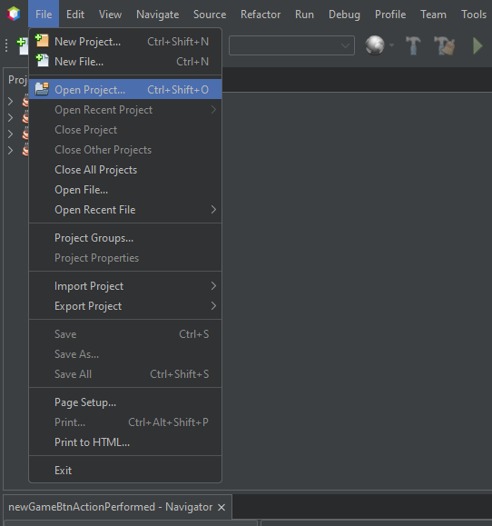

5. Open up the subfolder “<default package>” in the Hangman folder and double click Hangman.java.

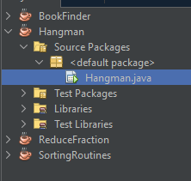

6. Click the run program button and enjoy the game! Note - See the how to use portion of the user guide if you are having trouble with playing.



[How to use]

1. Click New Game.

2. Enter one letter in the text field under the Enter Guess text to try and guess the mystery work and click the guess button.



3. Repeat Step 2 by guessing different letters to try and solve the word until you run out of guesses or find the word.

4. After the word has been solved, the next button should then be enabled and able to be pressed. Click the next button.



5. Rinse and repeat steps 2-4 to keep guessing new words and enhancing your knowledge.

6. When you are done click the close game button.



7. A text document (lastscores.txt) will then be created in the game directory with how you did during the game. Please be encouraged to share your results with your friends and see who can get the highest score!

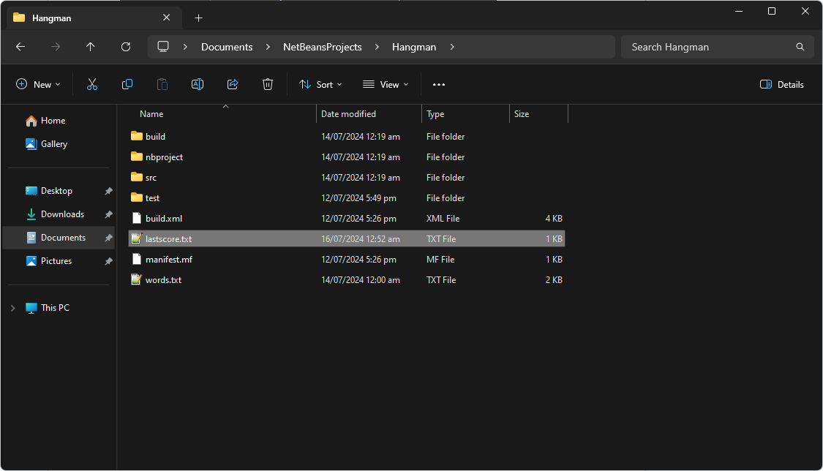

8. Thank you for playing my game, you now know how to play the game. Have fun!

[Key Features]

**Score System**

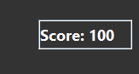

**Win/Loss Scoreboard**

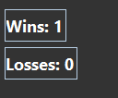

**Output File with scores**

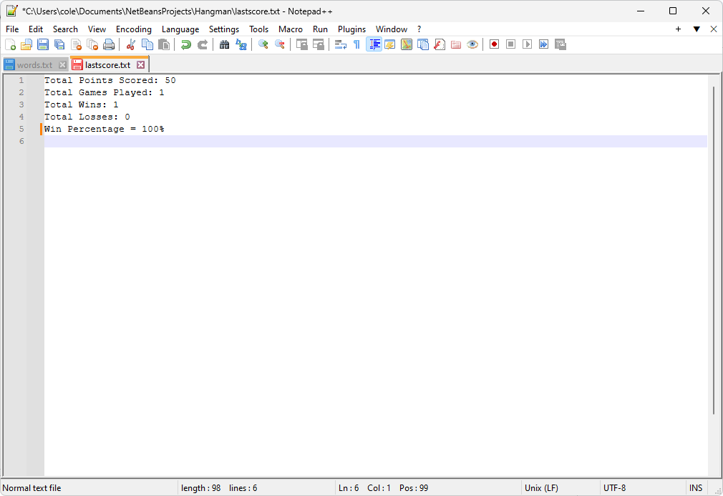

**Changing Display based on game action**

